**Pavan kumar Quiz 2**

1. Ruby program when that accepts a date in a month and prints it out the appropriate suffix. For example, for 1 as input, print 1st, 2 as input 2nd, 3 as input 3rd etc

1. Write your own ruby program using a case statement

Ans) #!/usr/bin/ruby

print "Enter your grade: "

grade = gets.chomp

case grade

when "A"

puts 'Excellent!'

when "B"

puts 'Gud!'

when "C"

puts 'Fair'!!!'

else

puts "take test again!"

end

Output:-

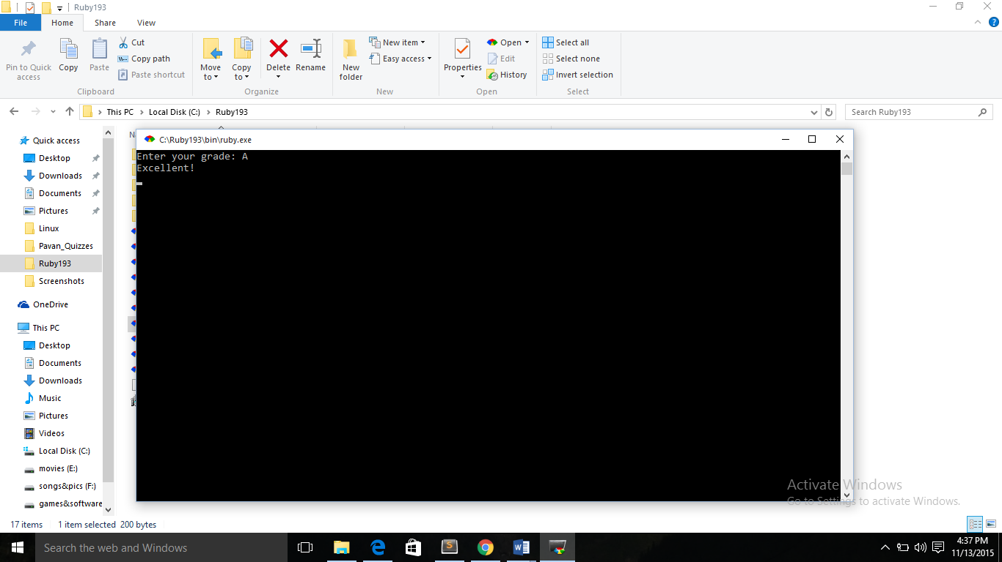

1. Ruby Program that iterates numbers with upto loop

Ans) #!/usr/bin/ruby

8.upto(16) { |i| print i, " " }

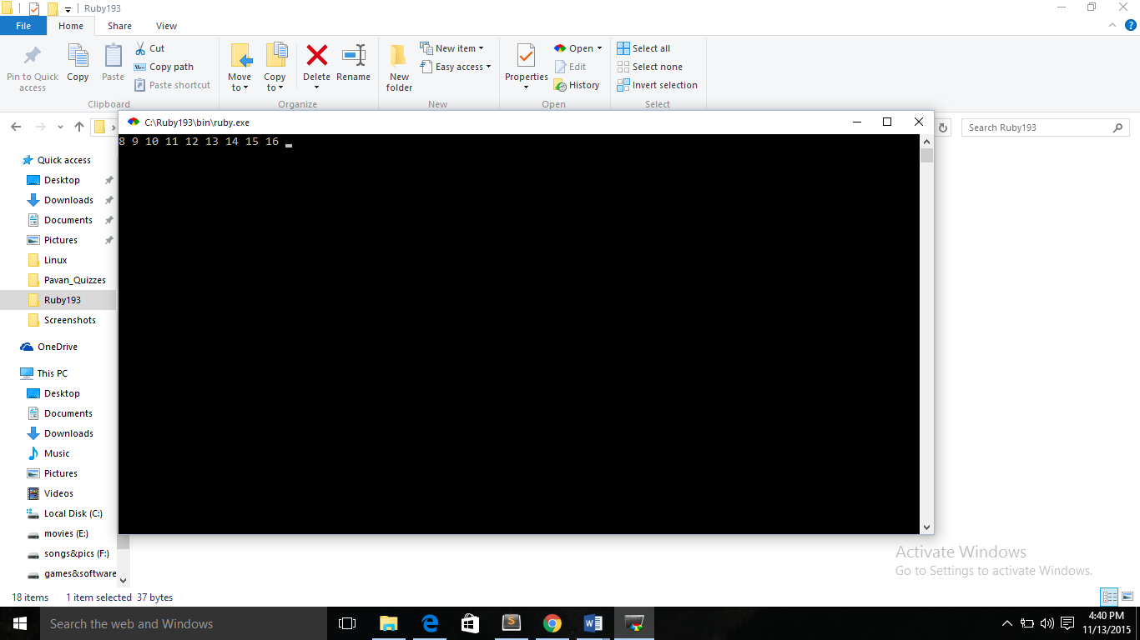

1. Write a Ruby program to print numbers from 1 to 50 and also in reverse order

Ans) #!/usr/bin/ruby

for n in 50.downto( 0 ) do

puts n

end

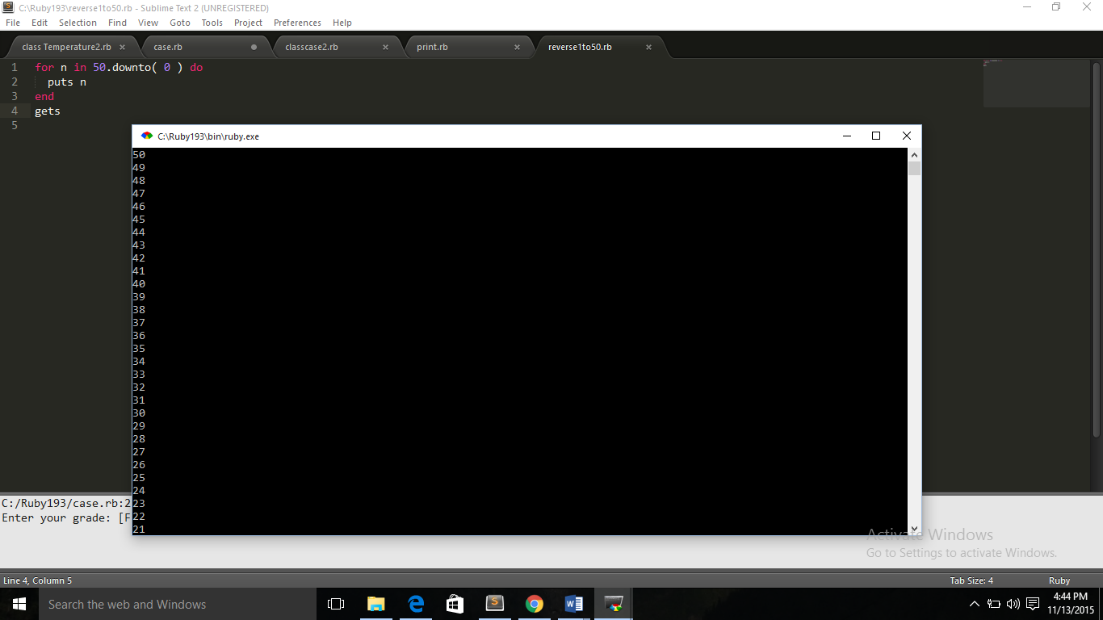

1. Write your own Ruby program using loops and iterators. Explain the difference between loops, iterators and blocks

Ans) #!/usr/bin/ruby

i = 10

while i < 60

puts i

i += 10

6.times do

puts "i"

end

end

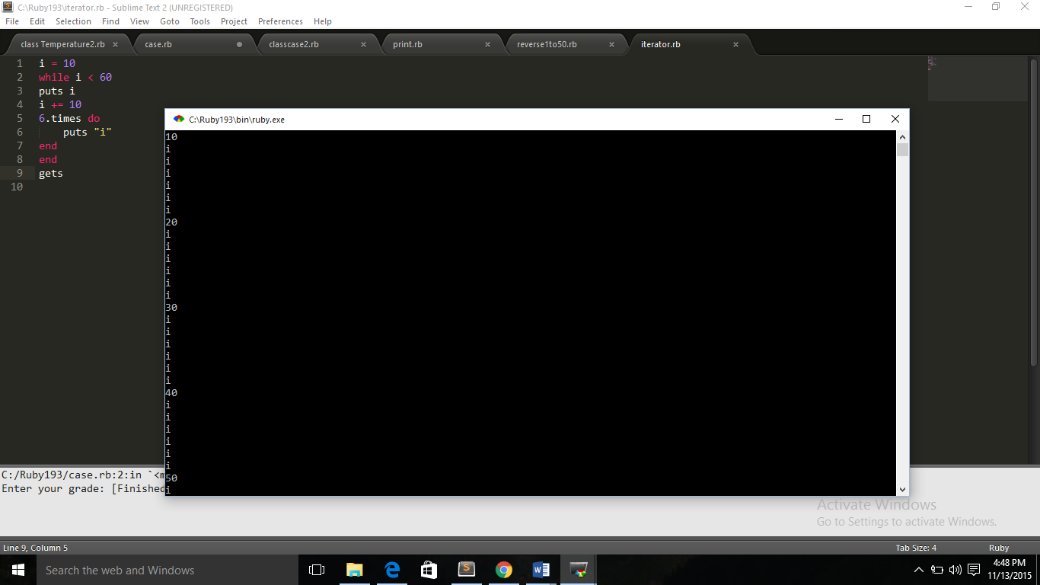

6. Write a Ruby program that loops through a array and checks if a pattern existsin the array elements

Ans) user = ["Pavan","lissy","levi"]

for i in 0..users.length-1

if user[i]=="lissy"

puts" the pattern is found"

else

puts "the pattern is not available"

end

end

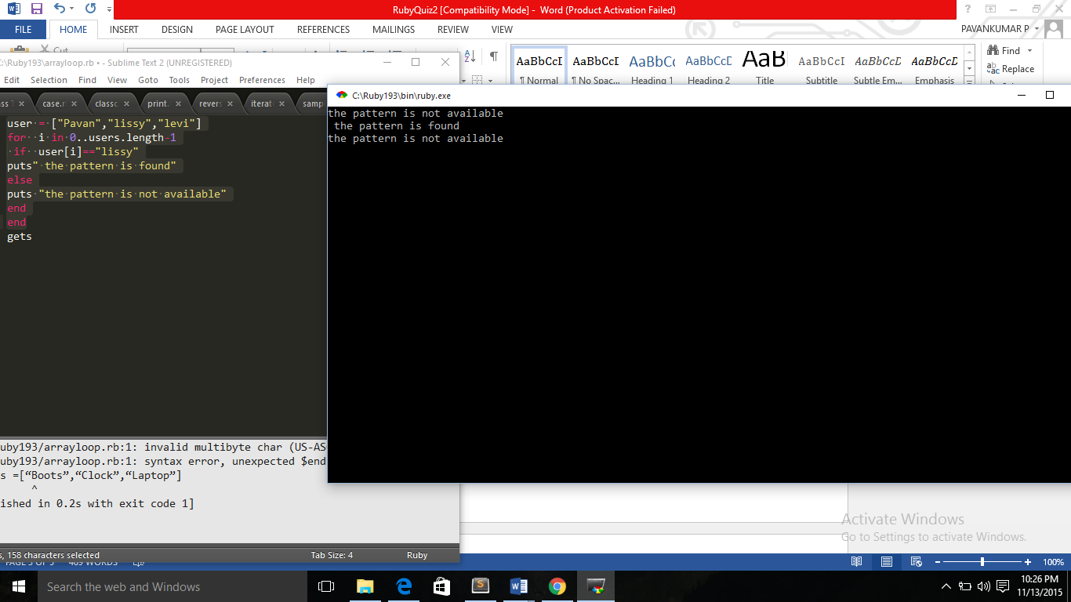

7. Write your own Ruby program using a Hash that loops through :

Print all Values while looping with Keys

Print all Keys while looping through Values

Print Keys, Values as pair.

Ans)

8. Write a Ruby program that takes number as input and recursively calculates the power of 2 until the calculated number is less than 10000 and prints the maximum power for that number.

Ans

9. Ruby program to convert Celsius temperature to Fahrenheit

Ans) #!/usr/bin/ruby

puts "Current temperature:"

current_temperature = gets.strip.to_f

puts "Is this in celsius or Fahrenheit? [C/F]"

original_temperature = gets.strip[0].downcase

if original_temperature == 'c'

new_temperature = (current_temperature * 5 / 9) + 32

puts "New temperature: #{new_temperature} F"

elsif original_temperature == 'f'

new_temperature = (current_temperature - 32) * 9 / 5

puts "New temperature: #{new_temperature} C"

else # Can't process anything else

puts "Don't recognise temperature scale: #{original_temperature}"

end

Output:-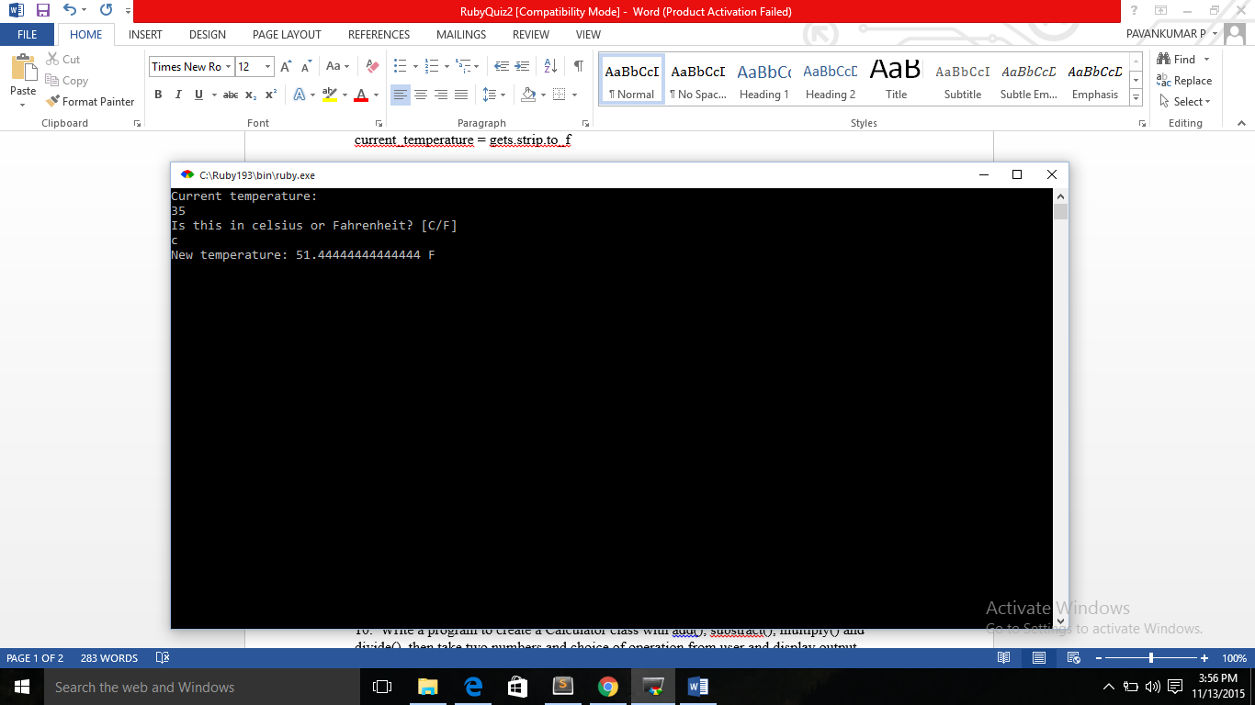

10. Write a program to create a Calculator class with add(), substract(), multiply() and divide(), then take two numbers and choice of operation from user and display output using objects